For immediate release
BBC Children in Need’s Got It Covered album is certified Silver as Shaun Dooley’s track is confirmed to be in the race for Christmas no.1
BBC Children in Need’s 2019 album featuring the likes of Olivia Colman CBE, Shaun Dooley, David Tennant and Jodie Whittaker has secured a Silver album certification, having sold more than 67,000 copies in recent weeks
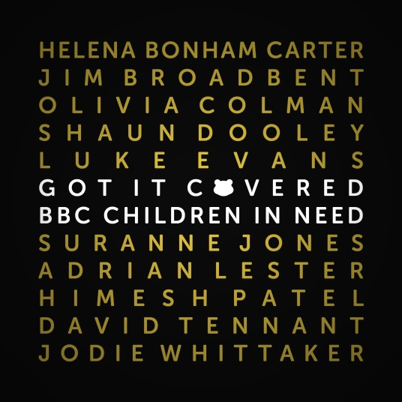
BBC Children in Need’s Got It Covered album, featuring some of the UK’s biggest names from stage and screen, has captured the imagination of supporters across the UK and has officially secured a Silver album certification.
The news was formally announced when a delighted Jodie Whittaker was surprised with a Silver certified album plaque in a special moment at the record of The Graham Norton show.
Jodie Whittaker, commented on the news: “It was such an amazing surprise to get the silver disc for recognising over 67,000 sales for Children in Need. Hopefully we can get to gold - or even platinum - because you never know!!!!”

A whole host of critically-acclaimed actors volunteered their time to play a special part in this incredibly exciting album for BBC Children in Need, including:
- Helena Bonham Carter CBE who covered Both Sides Now by Joni Mitchell
- Jim Broadbent who covered Blue Moon by Various Artists
- Olivia Colman CBE who covered Glory Box by Portishead
- Shaun Dooley who covered Never Grow Up by Taylor Swift
- Luke Evans who covered Smile by Nat King Cole
- Suranne Jones who covered Symphony by Clean Bandit
- Adrian Lester OBE who covered I Wish by Stevie Wonder
- Himesh Patel who covered All These Things That I’ve Done by The Killers
- David Tennant who covered Sunshine on Leith by The Proclaimers
- Jodie Whittaker who covered Yellow by Coldplay

The album, which is still available to purchase on the BBC Children in Need website here -also features a special group cover of It Must Be Love by Labi Siffre.

Each track was carefully crafted and recorded at the legendary recording studios, Abbey Road and Rak Studios in London. The actors received expert guidance and mentoring from Brit and Mercury award-winning record producers and songwriters, Guy Chambers and Jonathan Quarmby whilst renowned vocal coach Mark De-Lisser helped the artists record their tracks and Steve Sidwell conducted the BBC Concert Orchestra. The making of the album - released on Silva Screen Records - was recorded as part of the 90-minute entertainment documentary, BBC Children in Need: Got It Covered, which was co-produced by BBC Studios and 20four7films and aired ahead of BBC Children in Need’s 2019 Appeal.

The 90-minute entertainment programme follows the entire recording process and explores all the behind-the-scenes action as the actors face the challenging task of laying down their bespoke tracks at the legendary recording studios Rak and Abbey Road Studios in London. The programme is currently available to view on BBC iPlayer now.
Actor Shaun Dooley, who masterminded the project, is delighted with the result, saying: “When we first started this project I never even thought about the possibility of us all having a number one selling album. Everyone who has contributed to this beautiful special album is incredibly proud of the money it has raised for BBC Children in Need – and to have attained silver certification really is the icing on the cake. Who knows, perhaps we are on our way to gold now!”

The Silver classification comes as Silva Screen Records release Shaun Dooley and the Grimethorpe Colliery Band’s rendition of Never Grow Up by Taylor Swift. Dooley’s single, in aid of BBC Children in Need, is out now and in the race for the coveted Christmas no.1 spot. .

Tommy Nagra, Director of Content at BBC Children in Need, commented: “This achievement is a testament to the remarkable efforts of every single person involved in the creation of this very special album and television programme. It is clear that Got It Covered has captured the imagination of audiences across the UK, and we cannot thank them enough for their support.”

All net profits from the album and single will go to BBC Children in Need, with a minimum of £1.50 per album (charity number 802052 in England & Wales and SC039557 in Scotland).

~ENDS~
For more information please contact henni.cardy@bbc.co.uk
Notes to Editors:
BBC Children in Need’s vision is that every child in the UK has a safe, happy and secure childhood and the chance to reach their potential. The charity will realise this vision by supporting, promoting and publicising work that addresses the challenges that children and young people face and work that builds their skills and resilience.
BBC Children in Need is currently supporting over 3,000 local charities and projects in communities across the UK that are helping children and young people facing a range of disadvantages such as living in poverty, being disabled or ill, or experiencing distress, neglect or trauma.
Further information on BBC Children in Need can be found at bbc.co.uk/pudsey
About BBC Studios

BBC Studios, a global content company with British creativity at its heart, is a commercial subsidiary of the BBC Group. Formed in April 2018 by the merger of BBC Worldwide and BBC Studios, it spans content financing, development, production, sales, branded services and ancillaries. BBC Studios’ award-winning British programmes are internationally recognised across a broad range of genres and specialisms.

It has offices in 22 markets globally, including seven production bases in the UK and production bases and partnerships in a further nine countries around the world. The company, which makes 2500 hours of content a year, is a champion for British creativity around the world and a committed partner for the UK’s independent sector. BBC Studios has revenue of £1.4bn, and returns around £200m to the BBC Group annually, complementing the BBC’s licence fee and enhancing programmes for UK audiences.

