For immediate release
Got It Covered heading for No.1 spot in the UK’s Official Album Chart for BBC Children in Need
BBC Children in Need’s 2019 album featuring the likes of Helena Bonham Carter CBE, Olivia Colman CBE, David Tennant and Jodie Whittaker secures the coveted No.1 spot in the midweek Official Chart Update – meaning the charity could be heading towards their first ever No.1 album!
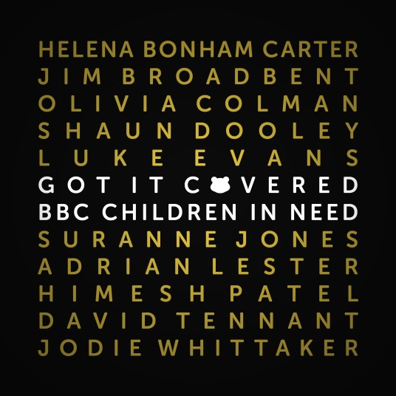
In just under a week, BBC Children in Need’s Got It Covered album, featuring some of the UK’s biggest names from stage and screen, has secured the No.1 spot in the midweek Official Chart Update, and could be heading to the No.1 spot in the UK's Official Albums Chart on Friday.
A whole host of critically-acclaimed actors volunteered their time to play a special part in this incredibly exciting album for BBC Children in Need, including:
- Helena Bonham Carter CBE who covered Both Sides Now by Joni Mitchell
- Jim Broadbent who covered Blue Moon by Various Artists
- Olivia Colman CBE who covered Glory Box by Portishead
- Shaun Dooley who covered Never Grow Up by Taylor Swift
- Luke Evans who covered Smile by Nat King Cole
- Suranne Jones who covered Symphony by Clean Bandit
- Adrian Lester OBE who covered I Wish by Stevie Wonder
- Himesh Patel who covered All These Things That I’ve Done by The Killers
- David Tennant who covered Sunshine on Leith by The Proclaimers
- Jodie Whittaker who covered Yellow by Coldplay

The album also features a special group cover of It Must Be Love by Labi Siffre.

Shaun Dooley, who masterminded the project, is delighted with the result, saying: “When we began working on this incredibly special project many months ago, I couldn’t have dreamt that such a beautiful, joyful, heartfelt album would be produced. The fact that it is no.1 in the midweek album chart and heading towards the no.1 spot on Friday really is the icing on the top of what truly has been the most incredible few months. The album is still available to purchase now, so please do show your support for BBC Children in Need and grab a copy!”

Mel Balac, Executive Producer and Creative Director at BBC Studios says: “The actors expressed themselves with a candid and touching honesty, both on record and on camera. The process of recording cover songs that hold such special meanings to each individual actor has touched the nation’s heart and the response has been overwhelmingly positive. BBC Studios is immensely proud and honoured to have been part of this unique project for BBC Children in Need – big Pudsey high fives all around to everyone that has helped make this album become the smash hit it truly deserves to be.”

The album is available to purchase on the BBC Children in Need website here.

Each track was carefully crafted and recorded at the legendary recording studios, Abbey Road and Rak Studios in London, whilst the actors received expert guidance and mentoring from Brit and Mercury award-winning record producers and songwriters, Guy Chambers and Jonathan Quarmby, and conducted by Steve Sidwell with the BBC Concert Orchestra, renowned vocal coach Mark De-Lisser also came on board to help the actors produce their tracks. The album - released on Silva Screen Records - was recorded as part of the 90-minute entertainment documentary, BBC Children in Need: Got It Covered, which was co-produced by BBC Studios and 20four7films and aired on BBC One last Wednesday. The entertainment documentary is currently available to view on iPlayer here and will be repeated on BBC One after the 2019 Appeal show at 12.30am on Saturday 16 November 2019.

All profits from the album will go to BBC Children in Need, with a minimum of £1.50 per album (charity number 802052 in England & Wales and SC039557 in Scotland).

~ENDS~
For more information please contact henni.cardy@bbc.co.uk
Notes to Editors:
About BBC Children in Need
BBC Children in Need’s vision is that every child in the UK has a safe, happy and secure childhood and the chance to reach their potential. The charity will realise this vision by supporting, promoting and publicising work that addresses the challenges that children and young people face and work that builds their skills and resilience.
BBC Children in Need is currently supporting over 3,000 local charities and projects in communities across the UK that are helping children and young people facing a range of disadvantages such as living in poverty, being disabled or ill, or experiencing distress, neglect or trauma.
Further information on BBC Children in Need can be found at bbc.co.uk/pudsey
About BBC Studios Production

BBC Studios Production makes around 2000 hours of content annually for the BBC and other UK and international broadcasters and received 79 awards and over 300 nominations over the past year, making it the most awarded producer in the UK. Spanning drama, comedy, factual, factual entertainment, entertainment, music and events, its award-winning credits include Blue Planet II, Doctor Who, Luther, Good Omens, This Country, Famalam, The Planets, 8 Days: To the Moon and Back, Louis Theroux and Killed By My Debt, as well as much-loved long-running series like Top Gear, Strictly Come Dancing, EastEnders, DIY SOS and Countryfile. Since launching as a commercial business in April 2017, BBC Studios has won over 30 third-party commissions, including commissions from Apple, National Geographic, Channel 4, Sky, UKTV, Channel 5, Discovery, PBS, Quibi, ABC in Australia and Migu in China.

