Immediate release: Friday 15 November 2019, 10pm

The nation Get Together to support BBC Children in Need’s 2019 Appeal, raising an incredible £35 million total at 10pm – with two and a half hours still to go!

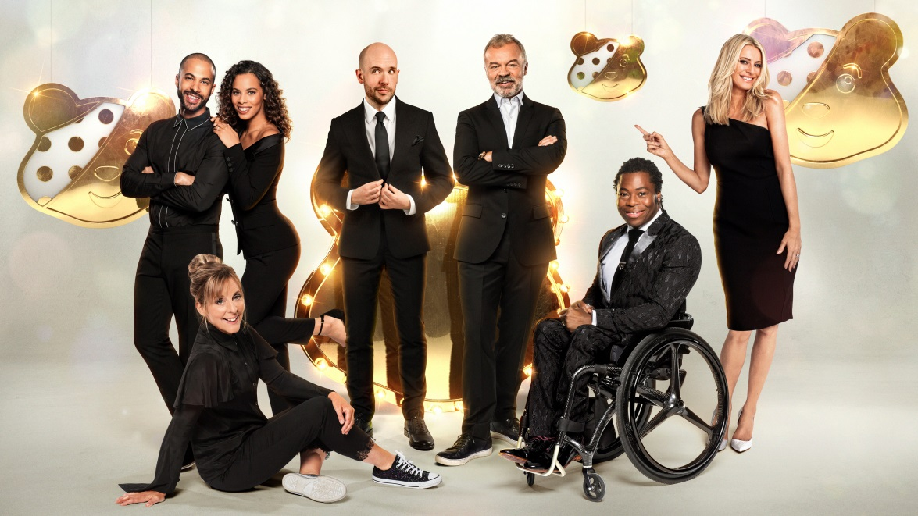

Only two and a half hours into BBC Children in Need’s 2019 Appeal on BBC One and the British public has already raised an incredible £35,383,512 to help change the lives of disadvantaged children and young people right here in the UK.

Ade Adepitan and Tess Daly kicked off the star-studded show live from BBC Elstree at 7.30pm. A spectacular opening performance came from the cast of the hit West End show Big, including Jay McGuinness, Kimberley Walsh, Matthew Kelly and Wendi Peters who took to the stage and kicked off the night with a bang. The performance was arranged especially for BBC Children in Need, and poignantly featured four young people who have previously been supported by BBC Children in Need funded projects.

A moving VT saw England’s Harry Kane, Marcus Rashford and Raheem Sterling join TV presenter Mark Wright in surprising children from the England Amputee Football Association, one of the many organisations benefiting from support from BBC Children in Need.

There was slime galore when presenters Sam and Mark brought children’s TV favourite - Crackerjack - back for BBC Children in Need.

A very special moment on the show saw an incredible young girl who has been supported by a BBC Children in Need funded project being surprised live on stage by Doctor Who stars Tosin Cole, Mandip Gill and the Doctor herself, Jodie Whittaker.

Joe Wicks, The Body Coach, was live in the studio to celebrate the remarkable fundraising efforts of schools up and down the UK. This year, Joe teamed up with the charity as its first ever Schools Ambassador to inspire and empower thousands of schoolchildren to get fundraising for BBC Children in Need’s 2019 Appeal, whilst getting active and feeling good.

The marathon fundraising effort was then taken over by Mel Giedroyc and Graham Norton who led the show through some spectacular moments, including the finale of The One Show’s Rickshaw Challenge. The challenge saw Matt Baker and six inspirational young people who have benefited from BBC Children in Need funding, cycle the rickshaw 400 miles from Holyhead to BBC Elstree Studios, raising a remarkable £5.5 million along the way. Sir Tom Hunter and Lady Marion Hunter joined the team on the stage to celebrate the incredible total. The Hunter Foundation (THF) had pledged to give 40p for every £1 donated by the general public to the Rickshaw Challenge, but generously announced that they were donating £3 million, bringing The Rickshaw Challenge’s 2019 total to a whopping £8.5 million.

Another standout moment from the show saw Popular YouTube star, Colin Furze, being challenged by two of the cast of Star Wars: The Rise Of Skywalker - Daisy Ridley and John Boyega - to make a real working landspeeder from the first ever Star Wars to mark the culmination of the biggest film sagas of all time. Young people from BBC Children in Need funded projects supported him as he worked to get it ready for Appeal night.

Elsewhere, Rylan Clark-Neal joined Graham and Mel on stage to celebrate Radio 2’s incredible fundraising total for 2019, a whopping £2 million. Earlier this week, bona fide karaoke king - Rylan Clark-Neal, undertook a 24 hour non-stop karaoke challenge to raise money for BBC Children in Need, raising an incredible £1 million which contributed to Radio 2’s amazing total.

A sparkling Strictly Come Dancing special saw EastEnders’ stars bidding to win the Pudsey Glitter Ball trophy. The special saw Ricky Champ, Louisa Lytton, Maisie Smith and Rudolph Walker OBE taking to the dancefloor with the Strictly pros, with Maisie Smith and professional partner Kevin Clifton lifting the 2019 Pudsey Glitterball trophy.

The real stars of the night however have been the children and young people who have featured in the Appeal films and shared their stories about how, with support from BBC Children in Need funded projects, they have been able to transform their lives, and it’s all thanks to the generosity of people across the UK and their fundraising efforts.

Other highlights so far have included:

- A spectacular performance from 1,399 children performing from nine different locations across the UK as they joined together to sing True Colours by Cyndi Lauper
- A performance from Louis Tomlinson of We Made It
- A breath-taking routine from the Circus 1903 stage show
- Alfie Boe and Michael Ball set the stage alight with a stunning performance of Something Inside So Strong
- Countryfile’s 2019 fundraising total being announced - a phenomenal £2.7 million
- Thank you moments to those across the country who’ve worked hard to raise money for the charity, including corporate partners

Last year, thanks to the generosity of the British public, BBC Children in Need were able to award millions of pounds in funding to projects right across the UK who support children and young people facing a range of disadvantages, including living in poverty, being disabled or ill or who have experienced distress or neglect, or trauma. In the last year alone, the charity was able to help change the lives of 600,000 disadvantaged children and young people.

It's not too late to get involved, either by calling the donation line on 03457 33 22 33 or visiting bbc.co.uk/pudsey.

The BBC Children in Need Appeal Show is a BBC Studios production, executive produced by Peter Davey and Barney Newman.
~Ends~
Further information:
- BBC Children in Need contact: henni.cardy@bbc.co.uk
- BBC Press Office: 020 8576 1865 / bbc.co.uk/pressoffice
Images
- Show pictures available from: bbcpictures.com or Dropbox
- Backstage pictures available here (Dave Hogan credit)
Notes to Editors
About BBC Children in Need
BBC Children in Need’s vision is that every child in the UK has a safe, happy and secure childhood and the chance to reach their potential. The charity will realise this vision by supporting, promoting and publicising work that addresses the challenges that children and young people face and work that builds their skills and resilience.

BBC Children in Need is currently supporting over 3,000 local charities and projects in communities across the UK that are helping children and young people facing a range of disadvantages such as living in poverty, being disabled or ill, or experiencing distress, neglect or trauma.

Further information on BBC Children in Need can be found at bbc.co.uk/Pudsey

About BBC Studios Production

BBC Studios Production makes around 2000 hours of content annually for the BBC and other UK and international broadcasters and received 79 awards and over 300 nominations over the past year, making it the most awarded producer in the UK. Spanning drama, comedy, factual, factual entertainment, entertainment, music and events, its award-winning credits include Blue Planet II, Doctor Who, Luther, Good Omens, This Country, Famalam, The Planets, 8 Days: To the Moon and Back, Louis Theroux and Killed By My Debt, as well as much-loved long-running series like Top Gear, Strictly Come Dancing, EastEnders, DIY SOS and Countryfile. Since launching as a commercial business in April 2017, BBC Studios has won over 30 third-party commissions, including commissions from Apple, National Geographic, Channel 4, Sky, UKTV, Channel 5, Discovery, PBS, Quibi, ABC in Australia and Migu in China.

