Strictly embargoed until 00.01 Thursday 3 October 2019
Stars join forces to launch BBC Children in Need’s 2019 campaign, asking the UK to Get Together to make a difference
Tess Daly, Rochelle Humes, Marvin Humes and Laura Whitmore amongst those supporting, encouraging the nation to Get Together to change children’s lives right across the UK
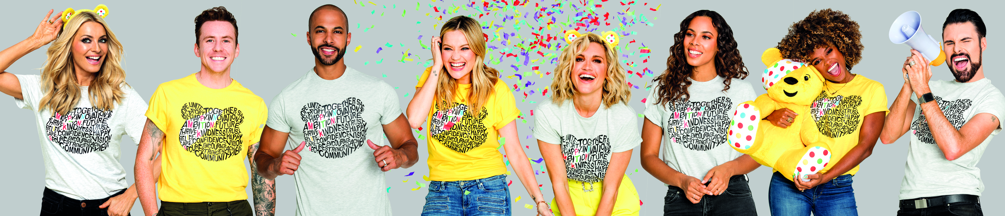
- Watch video here
- Supporting images available here
BBC Children in Need has today (Thursday 3 October) launched its 2019 fundraising campaign and is asking the nation to Get Together to help change the lives of disadvantaged children and young people in communities up and down the UK.
An incredible star studded line-up of famous faces have joined forces to support the Get Together campaign including Rylan Clark-Neal, Tess Daly, Fleur East, Marvin Humes, Rochelle Humes, Danny Jones, Ashley Roberts and Laura Whitmore. The celebrities are asking the nation to Get Together and fundraise to help make a positive impact on the lives of disadvantaged children and young people throughout the UK. From rambles to three-legged races, knit-a-thons to quizzes and once in a lifetime challenges to bake sales, everyone can Get Together to raise money for BBC Children in Need’s 2019 Appeal.

Strictly Come Dancing’s Tess Daly is urging everyone to show their support in 2019: “I am intensely proud to be supporting BBC Children in Need again this year. In the last year alone, BBC Children in Need has been able to make a real difference to 600,000 young lives in communities the length and breadth of the UK – that’s incredible, and it is all down to people up and down the UK coming together to help make a difference. I hope they do it again this year, because it really will change young lives.”

Long-term supporter Rochelle Humes has also thrown her support behind the 2019 campaign, saying: “Extraordinary things happen when people join forces to make a difference, and having worked with BBC Children in Need for many years I know the incredible things that are possible thanks to the public’s generosity. So come on everyone, Get Together to help make a difference to the lives of children and young people who really do need our support.”
Also championing the 2019 campaign is Marvin Humes who is calling on people across the UK to join in: “BBC Children in Need was one of my first experiences of charity, it was really powerful as a kid to find out that by simply doing things that I loved I could raise money which could go on to change someone else’s childhood. I have seen first-hand how that £10 raised through a bake-sale, or £20 raised through a quiz, makes an impact, so whatever you decide to do, just have fun – I promise it will go on to do great things.”
BBC Radio 2 presenter Rylan Clark-Neal has thrown his support behind the campaign, saying: “Whether you want to do something exhilarating like jumping out of a plane, or something simpler like spending the day in your pyjamas with your work mates, I promise you the money you raise will go on to make a difference. I personally recommend a donut bake-sale - I did that once at school and it was a very happy day! Whatever you decide to do this year, I hope you have a great time!”
Also supporting this year is TV presenter Ashley Roberts, who is calling on the nation to Get Together to change young lives, saying: “When we get together the smallest things can make a big difference, which is what makes BBC Children in Need so special. Every dance-a-thon, sponsored silence or slice of cake sold at a bake sale has the ability to change a young person’s life – how amazing is that? So come on everyone, let’s Get Together to make a difference!”
5Live presenter Laura Whitmore called on the Great British Public to Get Together to make a difference, saying: “The power of people uniting is remarkable, amazing things really can happen when we work together – and so I hope people across the UK have a great time getting together to support BBC Children in Need this year.”
The Voice Kids judge Danny Jones is encouraging the nation to get involved, saying: “What’s better than getting together with family or friends to do something that will go on to impact children and young people who need our help? BBC Children in Need currently fund over 3,000 local charities and projects in communities across the UK, and the chances are there will be a project just down the road from you, so come on everyone, let’s Get Together to help change young lives.”
Singer-songwriter Fleur East said of the 2019 campaign: “BBC Children in Need’s ability to bring people together is something I have always loved, and I am incredibly proud to be supporting this year’s campaign. Together, simple acts of kindness, like putting on a bake sale, can become a life-changing event for children and young people that really do need our support. So I’m urging everyone to Get Together and help make a difference.”
Simon Antrobus, Chief Executive at BBC Children in Need said: “Every year we are amazed by the remarkable efforts of supporters going above and beyond to make an impact on the lives of children and young people across the UK. Bringing people together sits at the heart of BBC Children in Need and we hope that our incredible fundraisers have a great time getting together in 2019, knowing it will help us give children and young people the childhood they deserve.”
BBC Children in Need’s official 2019 fundraising pack is available for download now from bbc.co.uk/pudsey and is bursting with ideas to inspire Get Together fundraising ahead of the 2019 Appeal show on Friday 15 November. To date the Great British public has raised over £1 billion for children and young people across the UK and the charity is calling on people to once again pull out all the stops and help make a difference!

~Ends~
For further information, images and interview requests please contact: henni.cardy@bbc.co.uk / 07711 348 725
- Get Together celebrity launch video can be found here
- All high-res Get Together images can be found here
- All low-res Get Together images can be found here
Notes to Editors:
BBC Children in Need’s vision is that every child in the UK has a safe, happy and secure childhood and the chance to reach their potential. The charity will realise this vision by supporting, promoting and publicising work that addresses the challenges that children and young people face and work that builds their skills and resilience.
BBC Children in Need is currently supporting over 3,000 local charities and projects in communities across the UK that are helping children and young people facing a range of disadvantages such as living in poverty, being disabled or ill, or experiencing distress, neglect or trauma.
Further information on BBC Children in Need can be found at bbc.co.uk/pudsey
Twitter: @BBCCiN
Facebook: @bbcchildreninneed
Instagram: @BBCCiN
#CiN

