Under strict embargo until 00.01 Monday 1 July 2019
Joe Wicks, The Body Coach, announced as BBC Children in Need’s first ever Schools Ambassador
Joe Wicks will encourage schools up and down the UK to get together and get active to help change young lives

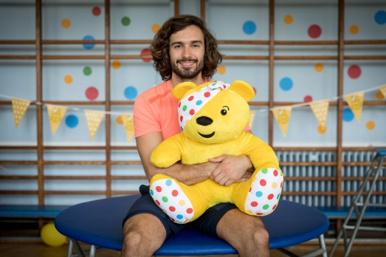

Today (Monday 1 July 2019), BBC Children in Need has announced that Joe Wicks has been appointed as the charity’s first ever Schools Ambassador. Joe Wicks has teamed up with the charity and its Official Education Partner Twinkl to inspire and empower thousands of schoolchildren to get fundraising for BBC Children in Need’s 2019 Appeal, whilst getting active and feeling good.

In addition to inspiring children to fundraise for the charity, Joe’s ambassadorial role will see him reprise his hugely popular Schools Tour programme to support the charity’s fundraising efforts. Ahead of BBC Children in Need’s 2019 Appeal ten lucky UK schools will receive a visit from Joe, where he will run a fun-filled mini workout session designed specifically for students and teachers. Schools simply need to register for a free fundraising kit before the end of September to be in with a chance of receiving a visit from The Body Coach himself.

The tour’s crescendo will see Joe undertake a live workout on Appeal day 2019 – Friday 15 November. The ‘Big Morning Move’ workout will be live-streamed to schools up and down the country with school children being encouraged and empowered to have fun and get active whilst raising money for the charity.
Joe Wicks commented on his new role, saying: “I am incredibly proud to be BBC Children in Need’s first ever School’s Ambassador, it really is an honour.”
“As a Dad, I am passionate about children’s health, wellbeing and happiness and hope that by inspiring children to get together, and get active, we can make a real and lasting impact.
“There is something amazing about children coming together to help other children, and I can’t wait to kick things off and see schoolchildren up and down the UK once again go the extra mile to make a difference!”
Simon Antrobus, Chief Executive at BBC Children in Need said of Joe’s appointment: “We are absolutely delighted that Joe has come on board as our Schools Ambassador. Joe’s commitment to transforming the lives of UK children for the better is remarkable, and we are certain that with Joe’s support this year, we will be able to make even more of an impact on young lives.”

To help make it easier than ever for schools to get involved, BBC Children in Need have teamed up with Twinkl Educational Publishing, their Official Education Partner, to produce fitness and wellbeing based resources. From healthy bakes to mindful arts and crafts these new materials will be part of a range of curriculum-based fundraising resources that will empower children across the UK to get together to make a difference.

The free resources will be available to download from the BBC Children in Need schools website and Twinkl’s website, for educators and schools to use from September onwards.

Jonathan Seaton, Co-founder and CEO of Twinkl said: “We are so proud to be working with BBC Children in Need and Joe to support schools across the UK to take part in healthy and fun activities and raise money. We’re creating some really exciting materials to support this and can’t wait to see schools in action.”

~ENDS~
For further information please contact Henni Cardy, BBC Children in Need on Henni.cardy@bbc.co.uk
Image credit: Joe Wicks preparing for BBC Children in Need’s 2019 schools campaign at De Bohun School in North London
Notes to editors
About BBC Children in Need
BBC Children in Need’s vision is that every child in the UK has a safe, happy and secure childhood and the chance to reach their potential. The charity will realise this vision by supporting, promoting and publicising work that addresses the challenges that children and young people face and work that builds their skills and resilience.
BBC Children in Need is currently supporting over 2,800 projects in communities across the UK that are helping children and young people facing a range of disadvantages such as living in poverty, being disabled or ill, or experiencing distress, neglect or trauma.
bbcchildreninneed.co.uk/schools
bbc.co.uk/pudsey
About Twinkl:
Twinkl was founded in 2010 by husband and wife Jonathan and Susie Seaton, with a mission ‘to help those who teach’. The company provides high quality, online learning materials and services, which are all teacher-created and checked.

Twinkl offers over 590,000 resources, with new content added daily. This ranges from schemes of work and assessments to augmented reality games and much more.

Twinkl is used and trusted by schools and educators in over 196 countries, including primary and secondary school teachers, nursery workers and parents.

The company also works in partnership with a range of organisations to support its mission and is proud to be the Official Education Partner of BBC Children in Need.

Founded in Sheffield, Twinkl now has over 500 team members based around the world and offices in Sheffield, Manchester and Australia.

More information can be found at twinkl.co.uk

