**Katie Melua to release BBC Children in Need’s official single for 2017**

*‘Fields of Gold’ re-recorded by Katie Melua as official single for charity’s 2017 Appeal in tribute to Life President Sir Terry Wogan*

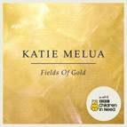

Katie Melua is to release this year’s official BBC Children in Need single, ‘Fields of Gold’.  One of Sir Terry Wogan’s favourite songs, ‘Fields of Gold’ was originally written and recorded by Sting, featuring on his 1993 album, ‘Ten Summoner’s Tales’.

After revealing the news live on BBC Radio 2 this morning, Katie said: “I am delighted to have accepted the invitation by BBC Children in Need to record and release this single to support the charity’s 2017 Appeal, in honour of the late Sir Terry Wogan.  He was a long-standing supporter of mine, and to re-record one of his favourite songs for a charity that was so dear to his heart is a privilege. I hope it goes on to make a real and lasting difference to the lives of disadvantaged children and young people across the UK.”

Recorded at Hoxa Studios in West Hampstead, Katie’s performance of this song sees her playing solo acoustic guitar accompanied solely by band-mate Mark Edwards on hammond organ. Co-produced and co-mixed by Katie Melua and Adam ‘Cecil’ Bartlett, ‘Fields of Gold’ is available as a stand-alone charity single from Friday 3 November, and will also feature as a bonus track on a reissue of Katie’s latest album ‘In Winter’, out 10 November.

Katie will give it its debut television performance live on the BBC Children in Need Appeal Show on Friday 17 November, at 9.50pm on BBC One.

The official BBC Children in Need single has a long history and, as the official artist behind this year’s release, Katie joins a long line of celebrated performers including Craig David, Jess Glynne, Gareth Malone’s All Star Choir, Ellie Goulding, and Girls Aloud.

All profits from the single will go to the charity, with a minimum of 60p from each single sale.

BBC Children in Need currently funds 2,600 projects supporting disadvantaged children and young people in communities across the UK.

**~Ends~**

For further information, images and interview requests please contact:  [henni.cardy@bbc.co.uk](mailto:henni.cardy@bbc.co.uk) / 07711 348 725

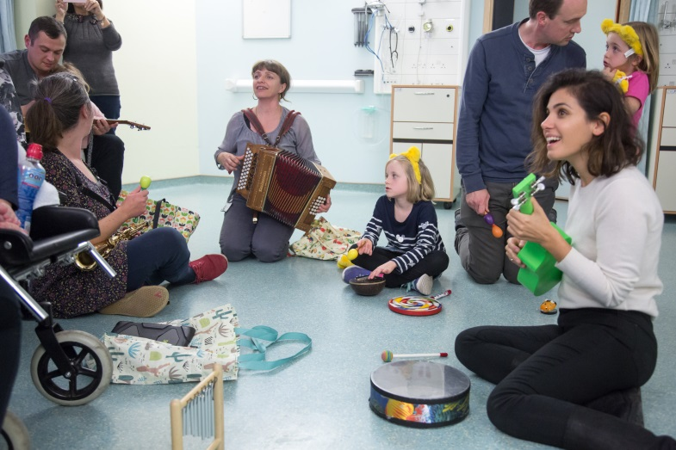

Katie Melua, who is releasing BBC Children in Need’s 2017 official single, ‘Fields of Gold’, meets children and young people at Rhythmix, a project supported by BBC Children in Need.

**Notes to Editors:**

BBC Children in Need’s vision is that every child in the UK has a safe, happy and secure childhood and the chance to reach their potential.  The charity will realise this vision by supporting, promoting and publicising work that addresses the challenges that children and young people face and work that builds their skills and resilience.

BBC Children in Need is currently supporting over 2,600 projects in communities across the UK that are helping children and young people facing a range of disadvantages such as living in poverty, being disabled or ill, or experiencing distress, neglect or trauma.

Further information on BBC Children in Need can be found at bbc.co.uk/Pudsey as well as our social media channels.