Famous faces launch latest BBC Children in Need T-Shirt
Joanna Lumley, Alesha Dixon and Edie Campbell amongst others show support for the Charity’s new Giles Deacon designed T-shirt
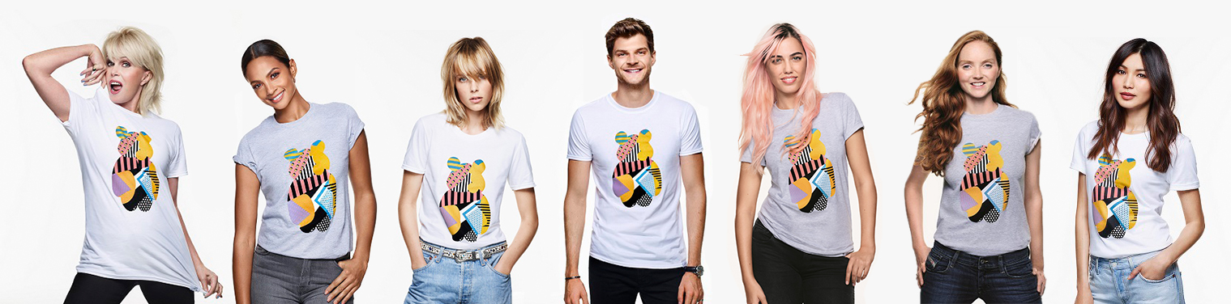
BBC Children in Need has today (Tuesday 18th October) launched its designer t-shirt with a striking collection of images featuring celebrity supporters. Joanna Lumley, Alesha Dixon, Amber Le Bon and Edie Campbell are just a few famous faces to have been snapped by fashion photographer Sølve Sundsbø to promote the garment, designed by Giles Deacon which is available to buy now.
The must-have item, combines designer style with goodwill, as money raised from sales of the T-shirt will go to benefit disadvantaged children and young people supported by the Charity across the UK.
Speaking of her involvement, Joanna Lumley commented; “I am delighted to be part of the BBC Children in Need 2016 campaign and encourage the UK to come together in doing what they can to help raise money for disadvantaged children and young people. You can show your support by buying a Pudsey T-shirt designed by Giles Deacon and wearing it with pride, knowing your support will go on to make a difference to young lives.”
Alesha Dixon, added; "Money raised from this year's BBC Children in Need T-shirt will go on to make a huge difference to the lives of disadvantaged children and young people. Designed by the fabulous Giles Deacon and featuring a pop art Pudsey! What's not to love? Get yours now!"
Commenting on the design, British model Edie Campbell said; “Giles Deacon never ceases to surprise with his designs and this year’s BBC Children in Need T-shirt is no different. I hope everyone will get their tee now and help raise money for disadvantaged children and young people.”
Amber Le Bon who also modeled the new T-shirt, mentioned; “Make the new Giles' Deacon designed BBC Children in Need tee the newest addition to your wardrobe. Whether you dress it up or down the design is sure to make a statement, show your support for the Charity and get yours today."
Model Lily Cole said; "I'm very happy to be supporting BBC Children in Need. Fashion fans can buy a Giles Deacon designed tee, whilst helping a good cause.”
Actress Gemma Chan added; "Show your support for BBC Children in Need by buying the lovely Giles Deacon designed t-shirt. Your support will go a long way in making a difference to the lives of children and young people across the UK."
Vlogger Jim Chapman shared his words of encouragement saying; "Join me in helping to raise money for disadvantaged children and young people by wearing your BBC Children in Need tee designed by Giles Deacon. The money will go towards making a huge difference to young lives, what are you waiting for?!"
Designer of the T-shirt, Giles Deacon spoke of his support for the Charity when he said; “Having supported BBC Children in Need for many years now, I was delighted to design this year’s T-shirt. Inspired by my love of bold graphics and colour, the T-shirt is a real pop art Pudsey. I encourage everyone everywhere to buy one and help make a huge difference to the lives of disadvantaged children and young people around the UK.”
The T-shirt features the Charity’s famous mascot, Pudsey, decorated in a geometric medley of colours and patterns. The 100% cotton T-shirts, which retail at £12, are available in white or grey and in sizes S, M, L and XL at www.bbc.co.uk/pudsey now. A contribution of 70% per T-shirt sold will benefit the Charity.
The annual BBC Children in Need Appeal Show will return to the nation’s television screens on Friday 18th November.
For more information, visit www.bbc.co.uk/pudsey
~ENDS~
For further information, quotes and images please contact:
Coco Stephens | coco.stephens@bbc.co.uk | 030 3080 7859 | +44 (0)7590 183559
Photo Credits:
Individual shots of Joanna Lumley, Alesha Dixon, Edie Campbell, Lily Cole, Amber Le Bon, Gemma Chan, Jim Chapman by Sølve Sundsbø are available here.

Photo Caption:
Get your hands on the new BBC Children in Need T-shirt designed by Giles Deacon, available at www.bbc.co.uk/pudsey
Notes To Editors
Product placement information:

Cost: £12.00
Designer: Giles Deacon
Sizes available in: S, M, L, XL
Colours available: white and grey
Available from: www.bbc.co.uk/pudsey

About BBC Children in Need:
BBC Children in Need’s vision is that every child in the UK has a safe, happy and secure childhood and the chance to reach their potential. We will realise this vision by supporting, promoting and publicising work that addresses the challenges that children and young people face and work that builds their skills and resilience.
The Charity is currently supporting 2,400 projects in communities across the UK that are helping children facing a range of disadvantages for example, poverty and deprivation; children who have been the victims of abuse or neglect or disabled young people.
The 2016 Appeal show is on Friday 18th November on BBC One.

