Stars come together to ask the public to get fundraising and Do Your Thing for BBC Children in Need’s 2017 Appeal!
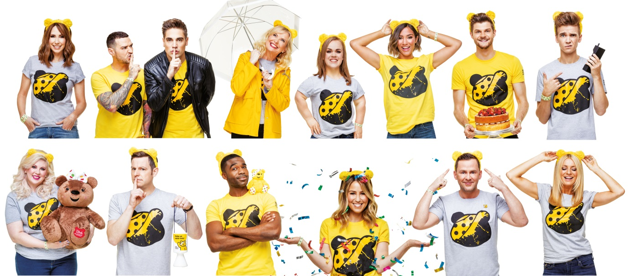
BBC Children in Need has today (Thursday 5 October) launched its fundraising campaign and is asking people across the UK to channel their passions, hobbies or dreams and Do Your Thing to help change the lives of disadvantaged children and young people across the UK.
An incredible star studded line-up of famous faces have come together to support the Do Your Thing campaign, including Matt Baker, Frankie Bridge, Jim Chapman, Tess Daly, Alex Jones, Carol Kirkwood, Scott Mills, Ore Oduba, Louise Pentland, Ellie Simmonds, Charlie Simpson, Rachel Stevens, Joe Sugg and Matt Willis. The celebrities are asking the nation to Do Your Thing and fundraise for BBC Children in Need. From fancy dress to clothes swaps, fun runs to once in a lifetime challenges, bake sales or sponsored silences, everyone can channel their passions into fundraising for BBC Children in Need.
The One Show and Countryfile presenter, Matt Baker said of the campaign: “Every year I see people up and down the country doing remarkable things to raise money for BBC Children in Need, and I can't wait to see what the UK public do again this year! You can do anything. Whether it's something you've always wanted to do, like an epic cycling challenge, or something that you're really good at like telling jokes or singing, you can turn anything into a fundraiser. So come on UK, Do Your Thing!”
Also supporting the campaign is former Saturdays star Frankie Bridge, who said: "I am so excited to be supporting BBC Children in Need again this year. It's such a worthy cause and everybody always has so much fun when they are fundraising. You really can do anything to raise money! Why don't you try a tech detox and live without your phone for a day, or maybe you could hold a clothes sale with your friends - whatever your thing is turn it into a fundraiser and the money that you raise will go on to make a real difference to young lives across the UK."
Strictly Come Dancing’s Tess Daly is also urging everyone to show their support in 2017: "BBC Children in Need is back, and I can't wait to see everyone across the UK doing their thing to raise money for the charity! Whatever you do, have fun and raise as much money as possible! It’s a cause that I am so passionate about and it really does make a difference to disadvantaged children and young people all over the UK."

Also championing the 2017 campaign is The One Show presenter Alex Jones who called on people across the UK to join in: "It's wonderful to be supporting BBC Children in Need again this year. Each year the public amazes me with the wild, wonderful and unique ways that they fundraise for the charity and I expect this year to be no different! Come on UK, Do Your Thing for BBC Children in Need."
BBC Radio 1 presenter, Scott Mills, who undertook an abseil down the ArcelorMittal Orbit for BBC Children in Need in 2015, called on the public to do all they can to support the 2017 Appeal, saying: “Whether you go to work in fancy dress, bake cakes for your family and friends or fancy taking on an adrenaline fuelled challenge - this year do your thing for BBC Children in Need and the money that you raise will go on to help improve the lives of children and young people in all corners of the UK. So what are you waiting for? Do Your Thing!"
Strictly Come Dancing’s 2016 glitter-ball champion, Ore Oduba, encouraged the nation to get involved, saying: "It's that time of year again - when the good people of the UK pull out all the stops to fundraise for BBC Children in Need! Whether it's by challenging yourself to a sponsored silence or putting on your best fancy dress; whatever your thing is, do it and make a difference to disadvantaged children and young people’s lives right here in the UK!"
Former S Club 7 star, Rachel Stevens, who has secured two number one singles with S Club 7 for BBC Children in Need, said of the campaign: "It's fantastic to be able to support BBC Children in Need this year. The charity does amazing work with children and young people all over the UK and I really hope that this year the public does their thing once again and raises lots of money for the cause. "
Simon Antrobus, Chief Executive at BBC Children in Need said: “BBC Children in Need is calling on people across the UK to once again come together to make a lasting, positive difference to the lives of disadvantaged children and young people. Whether you love baking or fancy dress, or fancy taking on a once in a lifetime challenge, you can use your passions to help change young lives.”
The official fundraising pack is available for download now from bbc.co.uk/pudsey and is bursting with ideas to inspire Do Your Thing fundraising ahead of the 38th Appeal show on Friday 17 November. To date the Great British public has raised over £909 million for children and young people across the UK and the charity is calling on people to once again pull out all the stops and help make a difference!
~Ends~
For further information, images and interview requests please contact: henni.cardy@bbc.co.uk / 07711 348 725
Notes to Editors:
BBC Children in Need’s vision is that every child in the UK has a safe, happy and secure childhood and the chance to reach their potential. The charity will realise this vision by supporting, promoting and publicising work that addresses the challenges that children and young people face and work that builds their skills and resilience.
BBC Children in Need is currently supporting over 2,500 projects in communities across the UK that are helping children and young people facing a range of disadvantages such as living in poverty, being disabled or ill, or experiencing distress, neglect or trauma.
Further information on BBC Children in Need can be found at bbc.co.uk/Pudsey as well as our social media channels:
#CiN
facebook.com/BBCChildreninNeed
twitter.com/BBCCiN
Additional quotes:
Jim Chapman: “I'm backing BBC Children in Need this year and encouraging everyone across the UK to do your thing for the charity! The money that you raise will go on to support projects that are working right here in the UK with disadvantaged children and young people. Whether you take on a once in a lifetime challenge, or do something that you really love, you can turn your thing into a fundraiser. So, go on UK, Do Your Thing!”
Carol Kirkwood: "I'm delighted to be supporting BBC Children in Need this year. I've seen first-hand some of the wonderful work that the charity supports with children and young people right here in the UK. Whatever your fundraising thing is, please do it and help us to raise even more money this year that will go on to make a difference to the children and young people that need it most in communities all over the UK."
Louise Pentland: "I'm so excited to be backing BBC Children in Need this year! Whether you love dressing up, are a whizz in the kitchen or want to challenge yourself to a week without your phone, you could turn any of these things into a fundraiser and Do Your Thing! All of the money that you raise will play a part in making a difference to children's across the UK. So go on, what are you waiting for? Do Your Thing!"
Ellie Simmonds: “BBC Children in Need is back again and this year I want to see the whole of UK do their thing for the charity. Whether you want to run a marathon, challenge your colleagues to a bake off or wear fancy dress for the day, there are plenty of ways that you can raise money. With your help BBC Children in Need will be able to continue supporting projects working with children and young people across the UK!"
Joe Sugg: "BBC Children in Need is back and I want to see people across the UK doing their thing to raise money for the charity. Your thing could be anything, from having a tech detox and locking away your phone, to spending a day being sponsored not to speak! Come on UK, Do Your Thing!"

