FOR IMMEDIATE RELEASE: Thursday 9 November 2017
Designers come together to create Pudsey Ears Collection for BBC Children in Need
The 2017 collection, curated by Katie Grand, has seen the likes of Burberry, Gucci and Louis Vuitton reimagine Pudsey’s iconic ears, modelled by famous supporters from around the world, including Adwoa Aboah, Kaia Gerber, Selena Gomez and Suki Waterhouse
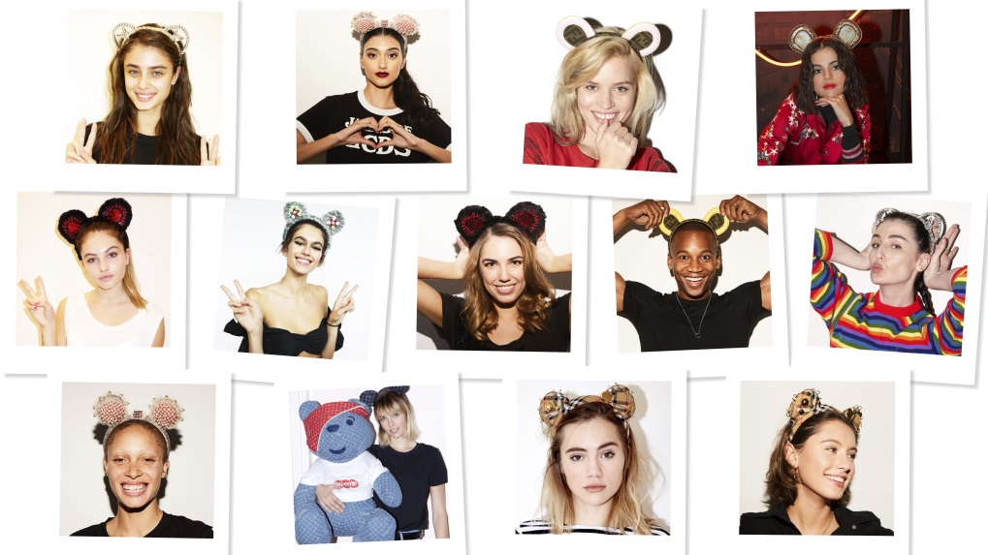
BBC Children in Need today (Thursday 9 November 2017) launched its first ever Designer Pudsey Ears Collection which features one-off headpieces designed by some of the biggest names in fashion and inspired by the charity’s mascot, Pudsey Bear.
Burberry, Coach x Selena Gomez, Fendi, Gucci, Louis Vuitton x Supreme, Miu Miu Prada and Tommy Hilfiger x Gigi Hadid have used their creative talents to contribute a bespoke creation to the exclusive collection of Pudsey Ears, curated by Katie Grand, LOVE magazine editor-in-chief and fashion stylist. The remarkable accessories are going to be auctioned off online and available to the highest bidder at www.bbc.co.uk/Pudsey from 9am, 9th November 2017 until 19th November 2017, with all proceeds going to BBC Children in Need.
The Designer Pudsey Ears have been recreated in an array of different fabrics from denim to leather; in a rainbow of different colours; and in a variety of different styles, from Gucci’s intricate, embroidered design, to Burberry’s classic print. Each pair is completely unique and will allow fans the opportunity to own a piece of fashion history, and to gain an insight into trends for 2017 and beyond.
In addition to the Designer Pudsey Ears, Louis Vuitton x Supreme have created a one-off unique 28 inch version of Pudsey Bear which is included within the collection. The highly covetable bear has been created using the final pieces of denim fabric from the brands’ iconic collaboration.
The Designer Pudsey Ears have been modelled by some of the fashion world’s most recognisable faces, including; Adwoa Aboah, Thylane Blondeau, Edie Campbell, Kaia Gerber, Neelam Gill, Selena Gomez, Taylor Hill, Georgia May Jagger, Iris Law, Amber Le Bon, Erin O'Connor, Eric Underwood and Suki Waterhouse.
Speaking of the collection, Katie Grand commented; “I am delighted to be involved in this year’s BBC Children in Need Appeal and to have curated the 2017 Designer Pudsey Ears Collection. What an incredible collection of exquisite designs! Each designer has surpassed themselves in adding their own unique identity to their headpiece.”
“I hope fashion fanatics across the UK and beyond are encouraged to get bidding on these fabulous creations. All money raised will go on to help support disadvantaged children and young people across the UK, so what are you waiting for?”
Those interested in bidding or in finding out more information on the 2017 Designer Pudsey Ears Collection can visit bbc.co.uk/pudsey Members of the public who miss out on the Designer Pudsey Ears Collection can still get their hands on a pair of Pudsey Ears priced from £2.50 via bbc.co.uk/pudsey.
-ENDS-
For more images or more information please contact coco.stephens@hotmail.co.uk
Notes to Editors:
The Designer Pudsey Ears Collection is being auctioned online via eBay, the online auction can be found here
BBC Children in Need’s vision is that every child in the UK has a safe, happy and secure childhood and the chance to reach their potential. The charity will realise this vision by supporting, promoting and publicising work that addresses the challenges that children and young people face and work that builds their skills and resilience.
BBC Children in Need is currently supporting over 2,600 projects in communities across the UK that are helping children and young people facing a range of disadvantages such as living in poverty, being disabled or ill, or experiencing distress, neglect or trauma.
Further information about BBC Children in Need can be found at bbc.co.uk/Pudsey

