Embargoed: 20:00 8th September 2019
COUNTRYFILE PRESENTERS CALL ON THE NATION TO GET TOGETHER, RAMBLE TOGETHER AND CHANGE YOUNG LIVES TOGETHER FOR BBC CHILDREN IN NEED
Programme’s presenting team challenge the nation to follow their lead and get rambling as the Countryfile Ramble for BBC Children in Need returns for its fifth successive year
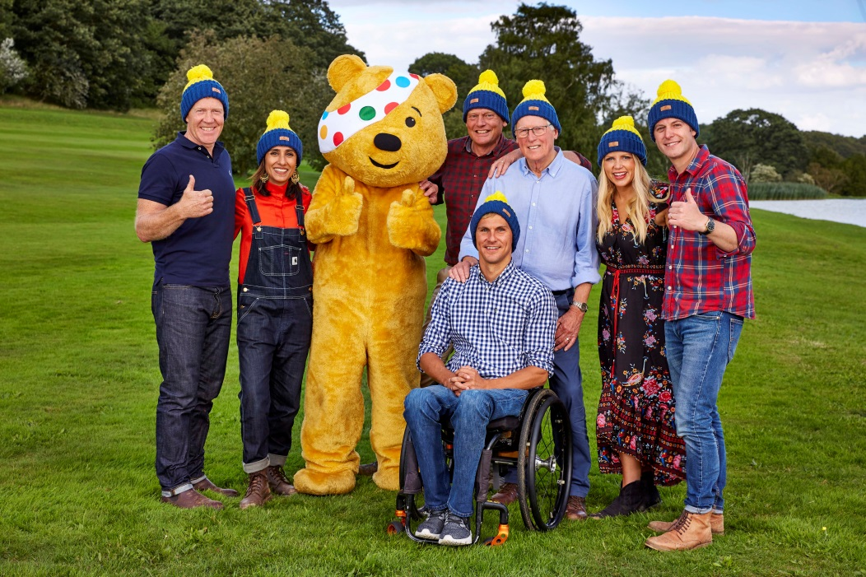
SUPPORTING IMAGES AVAILABLE HERE
Sunday 8th September: BBC Countryfile has this evening announced the return of the Countryfile Ramble for BBC Children in Need. Now in its fifth year, the return of the Ramble will see regular Countryfile presenters lacing up their walking boots this autumn, and leading rambles across the UK to help make a difference to young people’s lives.
Next month, presenters Matt Baker, Steve Brown, John Craven, Ellie Harrison, Tom Heap, Adam Henson and Anita Rani will be heading off to various locations across the UK to host rambles for BBC Children in Need. The presenters will be joined by viewers of the show and inspirational children and young people who have been supported by charities and projects funded by the charity.
Since the Countryfile Ramble began in 2015, ramblers have raised more than £6.2million for the charity. This year will once again see the presenters rambling in some of the nation’s most beautiful locations, including: Glenariff Forest Park in Northern Ireland, Scone Palace in Scotland, the Worcestershire riverside and the North Cornwall coastline. The rambles will take place on 5th and 6th October and will be filmed for a special programme, to be aired later in the month.
Ahead of the rambles, the presenters are once again calling on the public to get walking, talking, rambling and ambling for BBC Children in Need by doing their own sponsored rambles for the charity, which will help support disadvantaged children and young people across the UK.
Anita Rani will be leading a circular ramble around North Cornwall’s beautiful heritage coastline and inland routes that will take in stunning sea views and grassy hill top paths. Anita will be joined by 11-year-old Cara who has been supported by the Donna Louise Trust following the loss of her older sister Elle, last year.
Elsewhere, in Worcestershire, Ellie Harrison and Steve Brown will lead a mass ramble through the city of Worcester, where they will take in picturesque views of the River Severn and historic sights around the city. The pair will be joined on their ramble by more than 2,000 Countryfile viewers and 16-year-old Aaliyah who, following a diagnosis of Dilated Cardiomyopathy (CDM) – a condition which affects the heart muscle – has been supported by Cardiomyopathy UK. With the support of BBC Children in Need funding, Aaliyah has been able join a Youth Panel at Cardiomyopathy UK, where she meets with other young people with the same condition, and is able to talk and raise awareness about how this challenging condition affects her life.
In Scotland, John Craven will be leading a regal ramble around Perthshire’s Scone Palace, known for its magnificent architecture, stunning gardens and acres of beautiful woodland. Joining John will be 13-year-old Lucy, who was born with Spina Bifida & Hydrocephalus, a life-long condition that affects the spine and brain. Through BBC Children in Need funding, Spina Bifida Hydrocephalus Scotland is able to provide Lucy with the vital one-to-one specialised personal care that she requires.
In Northern Ireland, Adam Henson will be leading an adventurous ramble through Glenariff Forest Park in one of the Antrim Glens which will take in stunning waterfalls and conservation areas. Adam will be joined by a group of children from Focus on Family, a BBC Children in Need funded project, based in County Londonderry. Funding from the charity has allowed Focus on Family to develop the Eco-Warriors Club, a nature based activity programme for children aged 5-11 living on the Ballysally and Milburn Estate.
Meanwhile, Matt Baker will be taking on a challenging distance route – which will be announced at a later date – with 14-year-old Ethan, who was born with Spastic Diplegic Cerebral Palsy, a condition which affects his mobility. Using BBC Children in Need funding, Surfability Wales is able to provide Ethan with surfing lessons on specially adapted boards, giving him access to a fantastic sport for building confidence and having fun.
Countryfile presenter, Anita Rani said: “I can’t wait to pull up my walking socks and get rambling once again for BBC Children in Need this year. I’ve been lucky enough to take part in every Countryfile Ramble over the last four years, and to have met some truly inspiring children and young people in the process. Thanks to your donations, BBC Children in Need really can make a difference to the lives of disadvantaged children and young people across the UK. That’s why I’m really looking forward to seeing the public getting involved in their thousands again this year and leading their own rambles come wind, rain or shine; because together, we really can change lives.”
Tommy Nagra, Director of Content for BBC Children in Need said: “We are delighted to be teaming up with the Countryfile team once again to get the nation rambling this autumn. Taking part in a short sponsored walk or an ambitious hike makes a huge difference to the thousands of children and young people we support across the UK. It’s a terrific way to get together to support a fantastic cause.”
Since the Countryfile Ramble began in 2015, more than 4,500 people have joined the presenters on their rambles across the UK, collectively racking up thousands of miles.
This year, the public can join teams of walkers across the UK hosting a Countryfile Ramble for BBC Children in Need or set up their own and join the thousands rambling across the nations. To put on your own ramble, visit our Ramble Hub at www.bbc.c.uk/Pudsey to get walking and raising money for the charity.
The walks will take place in October and will be broadcast as an extended programme: The Countryfile Ramble for BBC Children in Need, on BBC One, Sunday 27th October.
-ENDS-
For more details on any of the rambles, images or interview requests, please contact: jack.jones01@bbc.co.uk
Notes to editors
The rambles will take place on Saturday 5th and Sunday 6th October. Due to health and safety requirements, we are unable to publicise the exact starting points of each walk.
The public can join in by putting on their own sponsored rambles and help the charity to cover the distance around the UK. Visit the charity’s ramble page, www.bbc.co.uk/pudsey, to set up a fundraising page. The public can also add their progress to the collective total and turn their miles into money.
About BBC Children in Need
BBC Children in Need’s vision is that every child in the UK has a safe, happy and secure childhood and the chance to reach their potential. The charity will realise this vision by supporting, promoting and publicising work that addresses the challenges that children and young people face and work that builds their skills and resilience.
BBC Children in Need is currently supporting over 3,000 local charities and projects in communities across the UK that are helping children and young people facing a range of disadvantages such as living in poverty, being disabled or ill, or experiencing distress, neglect or trauma.
For more information about BBC Children in Need and the projects we fund, please visit www.bbc.co.uk/Pudsey

